(01)Create a custom module which returns the sum and average of any two numbers passed into
it. Require the module and run the server by passing 123 and 321 so that the server prints out
the sum and average.
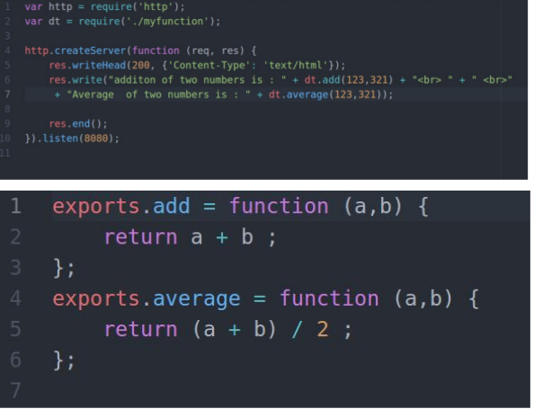
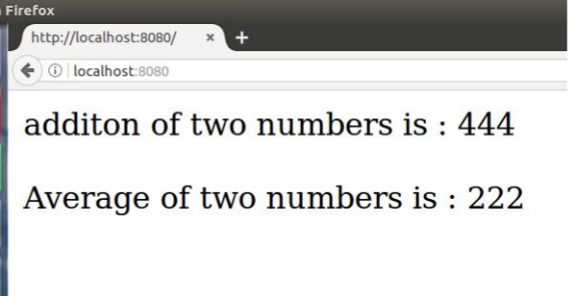

(02)Create a simple http server and print “Welcome to Uki. I am yourname” when a request is sent to your server via the port 8000. (Note - Change different port numbers and check)

(03)Using the file system module create a new file called ukinode.txt

3.1 Write a paragraph about Uki into that file.
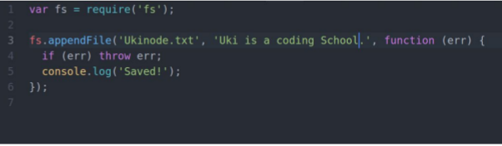
3.2 Serve that file to the client (Read File) over your server

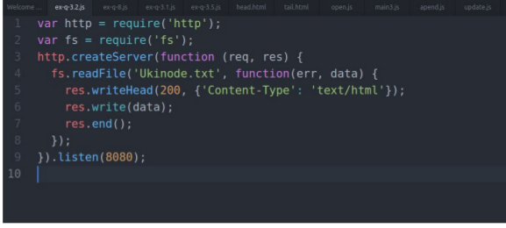
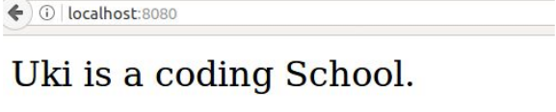
3.3 Append another paragraph about Uki and now serve the new file

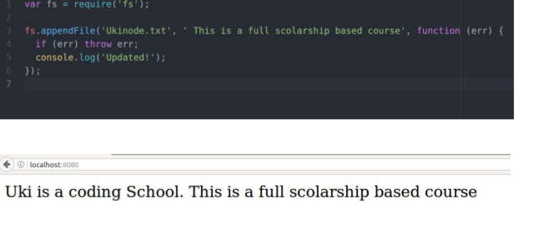

3.4 Rename the file as ukinodejsexercise1.txt

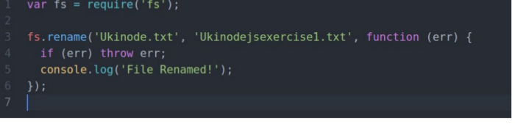
3.5 Delete the file you created

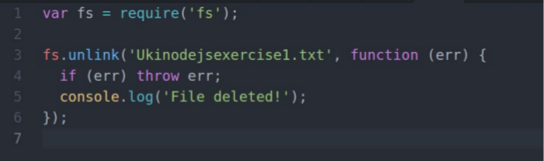

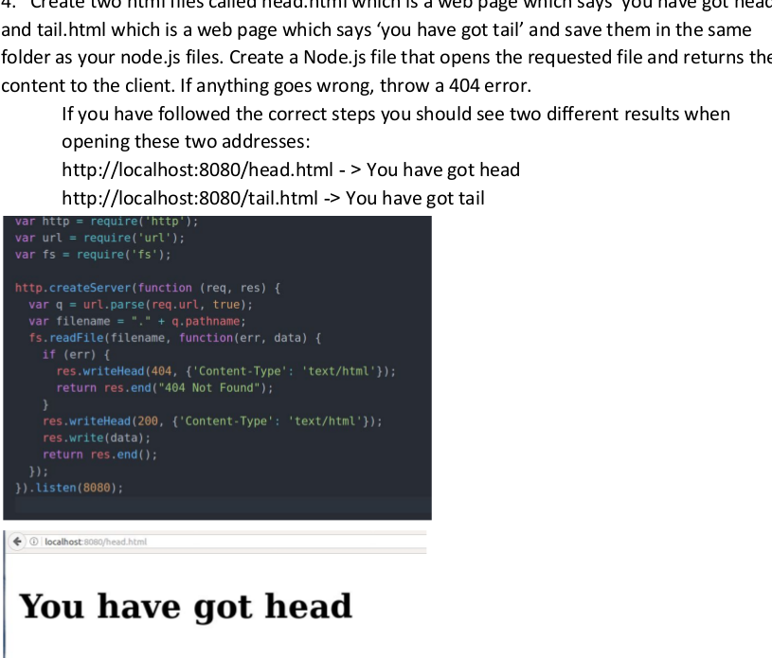

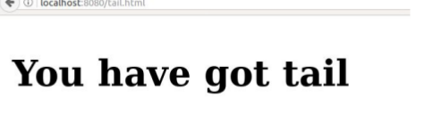

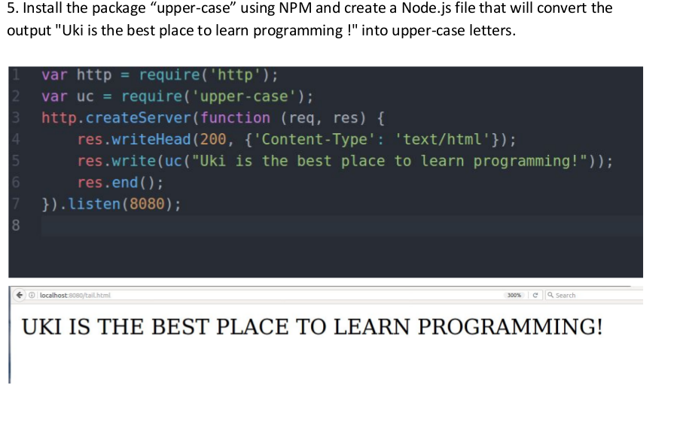
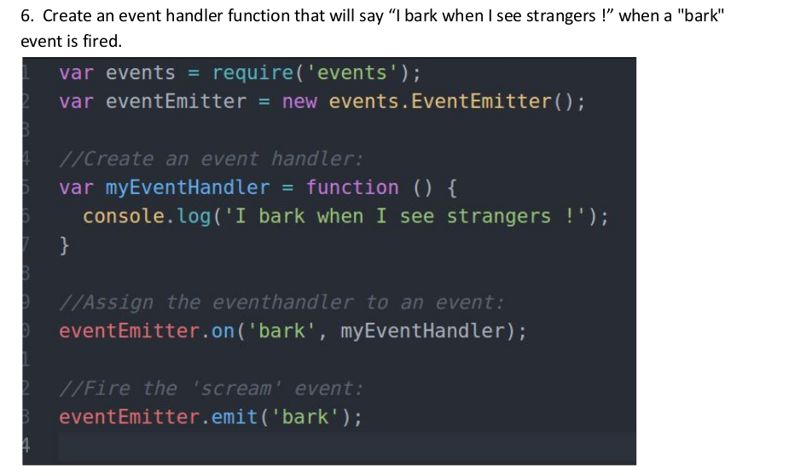

7. Install “formidable” module using npm and make a web page in Node.js that lets the user
upload files to your computer.
7.1 Save that uploaded file into your Documents directory.

8. Using the Nodemailer module create a server and send a mail to info@uki.life with the subject : “Testing my nodemailer module” , text: “This is easy !”
8.1 Now instead of text send a basic html formatted mail.

